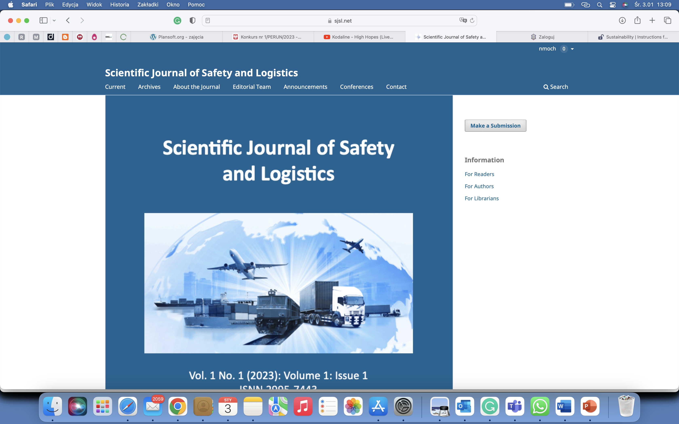

**Scientific Journal of Safety and Logistics**

Volume 2, Issue 1, 2024, ISSN 2995-7443

*Title*

Firstname Lastname 1, Firstname Lastname 2

1 Affiliation 1; scientific degree; e-mail@e-mail.com; phone number; ORCID number

2 Affiliation 2; scientific degree; e-mail@e-mail.com; phone number; ORCID number

**Abstract:** An abstract is a summary of a scientific publication. It should be condensed using only necessary words and explanations. The abstract is usually between 150 and 600 words. The abstract should be divided into: 1) *objectives*: to which question (or questions) sought for answer; 2) *methods*: methodology of conducted research; 3) *results*: what stated (data, dependencies); 4) *conclusions*: what conclusions were drawn. (in Polish and English)

**Keywords:** List three to five pertinent keywords specific to the article yet reasonably common within the subject discipline. (in Polish and English)

1. Introduction

The introduction should include the state of knowledge to date, the reason for the execution of the research and indicate the purpose of the article. The introduction is also intended to answer the reader's question: what has actually been done. The structuring of the introduction should be in the shape of a 'funnel', meaning that it should start with an overview and move on to progressively more detailed information. Illustrative sequence: outline of the general topic (background), summarising the state of knowledge so far (what is known), identifying the questions and gaps that have arisen (what is not known), justifying the research (why it is useful to find out what is not known), showing how the research in question affects the answers to these questions (the article's hypothesis or the question it answers).

The sources of all cited publications should be included in the references. Try to have at least 50% of literature indexed in international databases (such as Scopus, Web of Science, DOAJ, EBSCO). Below you will find an example of cite of the Harvard method, the only we accept. See the end of the document for further details on references.

2. Methodology or Materials and Methods

The methodology should describe in sufficient detail the research carried out to allow for repetition, identifying specific research methods, techniques and tools.

3. Results

The results should present what has been studied and the results obtained. They should also present new knowledge and highlight what is most important about it. In this section, it is recommended to use a graphical presentation of the results of the research.

*Figures, tables and schemes*

Figures and tables should be incorporated in the basic part of the text, close to the place of their citation; it is recommended that drawings be made in vector graphics programs; in addition, drawings should be saved as separate files in JPG format and attached to the main material; tables should be devised in a text editor (independently of the illustrations), have short titles and column headings; each figure and table shall be appropriately numbered, assigned with a title and their source; the figure title is to be provided under the figure, and the table title – over it.



**Fig. 1.** Title

(Source: Nowak, 2021, p. 3)

**Tab. 1.** Title

|  |  |  |
| --- | --- | --- |
| **Title 1** | **Title 2** | **Title 3** |
| data | data | data |
| data | data | data |

(Source: Kowalski, 2022, p. 10)

*Mathematical Components*

Mathematical formulae (written in the equation editor) contained in technical publications should be distinguished according to requirements; preference is given to SI units; among others, the following is necessary;

* use italics to indicate variables and one- and two-letter indices;
* use plain text for numerals, physical units (such as m, s, kg), physical and mathematical constants (e.g. number e, imaginary unit i), function names (sin, cos, tg, log, ln, etc.), three- and multi-letter word abbreviations in subscripts (const, kryt), chemical formulae and symbols.

4. Discussion

In this chapter, if needed you can compare the results with previously published data.

5. Conclusions

The conclusions should provide principles, correlations, generalisations, highlight exceptions to the rule and unexplored areas, show compatibility of the results obtained with the results of others, present conclusions, answer the question posed in the introduction, critically evaluate the research done, show its limitations and weaknesses, make possible generalisations and state what influences the impossibility of making major generalisations, highlight new knowledge and the conclusions drawn from it, describe the significance of the research, show how the information obtained can be further used, outline your recommendations for further research.

**Author Contributions:** Conceptualization, X.X. and Y.Y.; methodology, X.X.; formal analysis, X.X.; investigation, X.X.; resources, X.X.; data curation, X.X.; writing—original draft preparation, X.X.; writing—review and editing, X.X.; visualization, X.X.; supervision, X.X. All authors have read and agreed to the published version of the manuscript.

**Funding:** Please add: “This research received no external funding” or “This research was funded by NAME OF FUNDER, grant number XXX”.

**Acknowledgments:** In this section, you can acknowledge any support given which is not covered by the author contribution or funding sections.

**References**

**Cite Them Right 10th edition – Harvard**

|  |  |  |
| --- | --- | --- |
| **Type** | **In-text citation** | **Bibliography** |
| **Book** | (Lowenthal, 2007, p. 17) | Lowenthal, M.M. (2007) Strategic Arms Reduction Treaty (START III). Congressional Research Service. |
| **Book: Four or more authors** | (Lal *et al.,* 2018, pp. 12-19)Epstein *et al.,* 2008, p. 8) | Lal, B. *et.al.* (2018) *Global Trends in Space Situational Awareness (SSA) and Space Traffic Management (STM).* Science & Technology Policy Institute. |
| **Book section** | (Wood, 2003) | Wood, L. (2003) ‘Satellite Constellation Networks’, in Zhang, Y. (ed.) *Internetworking and Computing Over Satellite Networks.* Boston, MA: Springer US, pp. 13-34, doi: 10.1007/978-1-4615-0431-3­_2. |
| **Journal Article** | (Hassanifard et al., 2019) | Hassanifard, S. et al. (2019) ‘Fatigue life of axially loaded clamped rivet-nut joints: Experiments and analyses’, International Journal of Fatigue, 129, p. 105254. doi: 10.1016/j.ijfatigue.2019.105254. |
| (Christensen, 2019, p. 19) | Christensen, R. M. (2019) ‘Failure criteria for fiber composite materials, the astonishing sixty year search, definitive usable results’, Composites Science and Technology, 182, p. 107718. doi: 10.1016/j.compscitech.2019.107718. |
| **Web page** | (European Space Agency, 2019) | European Space Agency (2019). Available at: https://www.esa.int/. |
| **Article on the web page** | (NASA, 2019) | NASA (2019) NASA Organization Chart. Available at: https://www.nasa.gov/sites/default/files/atoms/files/agency_org_chart_mar_2019.pdf. |
| **Report** | (Harrison et al., 2020) | Harrison, T. et al. (2020) Space Threat Assessment 2020. |
| **Report on the web page** | (C4ADS raport, 2019) | C4ADS raport (2019). Available at: https://c4ads.org/reports. |

**Citation:** To be added by editorial staff.

Received: date; revised: date; accepted: date; published: date

|  |  |
| --- | --- |
| What Are the Different Types of Creative Commons Licenses? – POSETest | **Copyright:** © 2024 The material presented here is the property of the individual authors and it represents their viewpoints and research findings. Distribution will be done in: CC Attribution-NonCommercial NoDerivatives 4.0. (https://creativecommons.org/licenses/by-nc-nd/4.0/). |